Counterterrorism Intelligence Using Protocol Dissection and Multi-Source Correlation
Concept, architecture, information extraction, challenges, solutions, and prototype scope.

1. Objective
The objective is to design an authorized counterterrorism intelligence prototype that can collect network and telecom observations, identify and dissect protocols, extract useful technical information, correlate observations across time and protocols, build relationships between entities, and produce an evidence-based investigation priority or identity attribution when authorized identity records are available.
The central idea is not to identify a person from a single IP address. Instead, the system combines identifiers, metadata, sessions, communication relationships, temporal behavior, and authorized external records.

2. Core Concept
The diagram below traces the full path from a raw observation to an investigation priority.
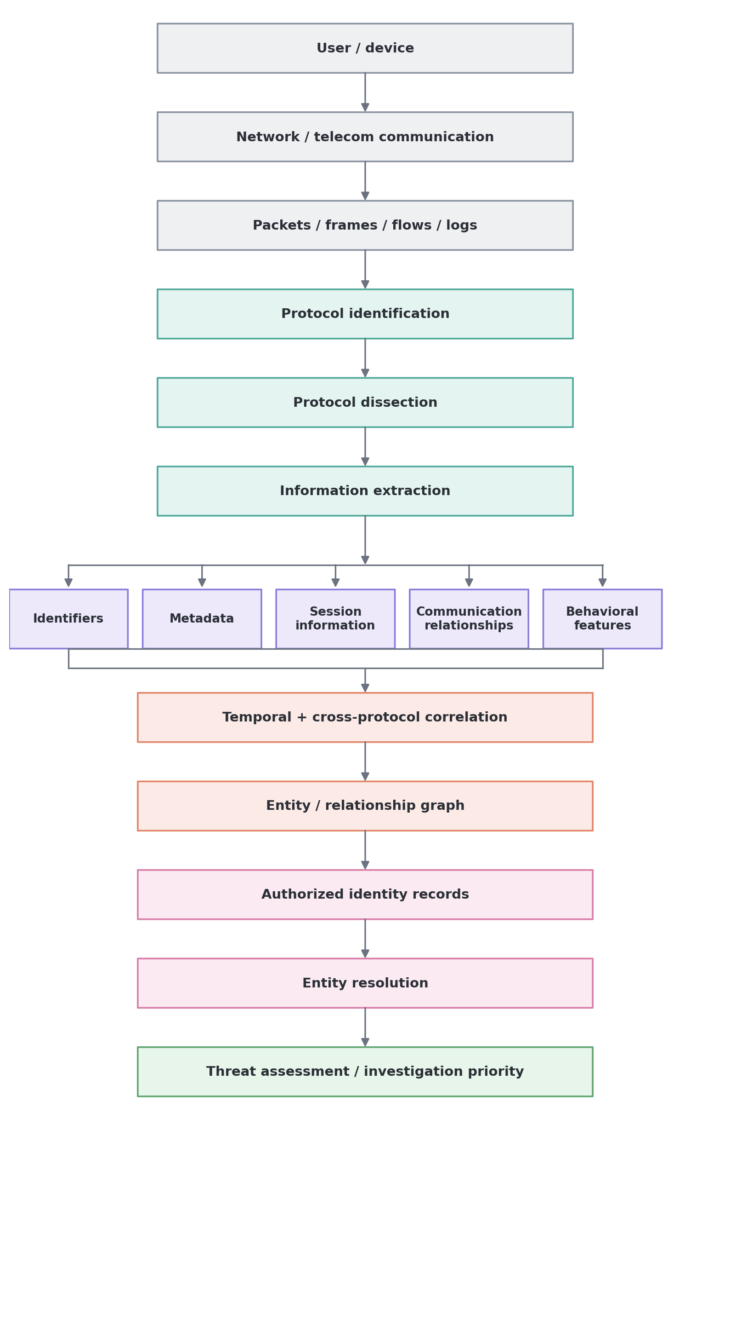
Figure 1. Core concept pipeline.

3. Important Principle: Protocol Dissection Does Not Directly Identify a Person
Protocol dissection interprets packets or protocol messages according to their specifications. It can reveal technical identifiers and metadata, but it normally does not prove the real-world identity of a person by itself.
A technically stronger model is:
Technical observation + Time + Session relationship + Cross-protocol correlation + Authorized identity records = Higher-confidence entity attribution

4. What Protocol Dissection Can Provide
Category | Possible information | Example
Network | Source/destination IP, ports, protocol | TCP 443, UDP 5060
Ethernet | MAC addresses, EtherType | Device A to gateway
DNS | Queries, responses, domain context | example-domain.com
TCP/UDP | Ports, flags, sequence/session behavior | TCP SYN/ACK
TLS | Handshake and session metadata where observable | TLS version
HTTP | Methods, hosts, paths and headers when visible | GET /api
SIP | Call/session signaling and identifiers | Call-ID, From, To, CSeq
SDP | Media/session parameters | Media address, port, codec
RTP/RTCP | Media transport metadata | SSRC, sequence, timestamp
DHCP | Address assignment context | Client requesting an address
Mobile | NAS, NGAP, GTP and session context | Registration/session relationships
O-RAN | Fronthaul and synchronization context | eCPRI/PTP traffic
Flow | Start/end time, bytes, packets, direction | 25 MB over 10 minutes

5. Protocol Priority for the CT Prototype
The following order provides a practical networking-first progression. The exact priority depends on the available data sources and operational environment.
Priority | Protocols | Why useful
1 | Ethernet, ARP, IPv4/IPv6 | Basic packet structure and local/network addressing
2 | TCP, UDP, ICMP, SCTP | Transport and control behavior
3 | DNS, DHCP | Network configuration and name resolution context
4 | TLS, HTTP/HTTP2/HTTP3 | Web and encrypted-session metadata
5 | SIP, SDP, RTP, RTCP | Voice and real-time communication
6 | NAS, NGAP, GTP-C, GTP-U, PFCP | 4G/5G telecom context
7 | BGP, OSPF, IS-IS | Routing and infrastructure context
8 | eCPRI, PTP, SyncE | O-RAN and RAN infrastructure context

6. High-Value Information Categories for Target Analysis
- Identifiers: IP, port, MAC where observable, session identifiers, telecom/application identifiers.
- Communication metadata: Source, destination, time, duration, direction, packet/byte counts.
- Session information: Session start/end, signaling-to-media relationships, transport associations.
- Application context: DNS domains, visible HTTP metadata, SIP/SDP information, service context.
- Device/network context: Access network, gateway, cell/site context where legitimately available.
- Relationships: Entity A communicated with entity B, repeated connections, shared infrastructure.
- Temporal behavior: Frequency, periodicity, bursts, changes from historical baseline.
- Historical baseline: Normal communication and network behavior for the observed entity.

7. Unusual Patterns That Can Generate Investigation Signals
An anomaly is not the same as a threat. The system uses unusual patterns as investigation signals and combines them with other evidence.
Pattern | Example interpretation
New communication relationships | An entity suddenly communicates with previously unseen entities.
Sudden behavioral change | Traffic profile changes significantly from the historical baseline.
Unusual traffic volume | A large deviation in bytes or packets compared with normal behavior.
Connection-rate anomaly | Connection frequency changes substantially over a short period.
Destination novelty | Many previously unseen destinations appear in a short period.
Protocol novelty | A protocol or service not previously observed appears unexpectedly.
Repeated session pattern | Similar sessions recur with unusual regularity or timing.
Cross-protocol correlation | Multiple protocols show related activity in the same time window.
Identity or address churn | Network identifiers change while other contextual relationships remain similar.
Infrastructure relationship | Several observations appear connected through common infrastructure or sessions.

8. Example: SIP + RTP Correlation
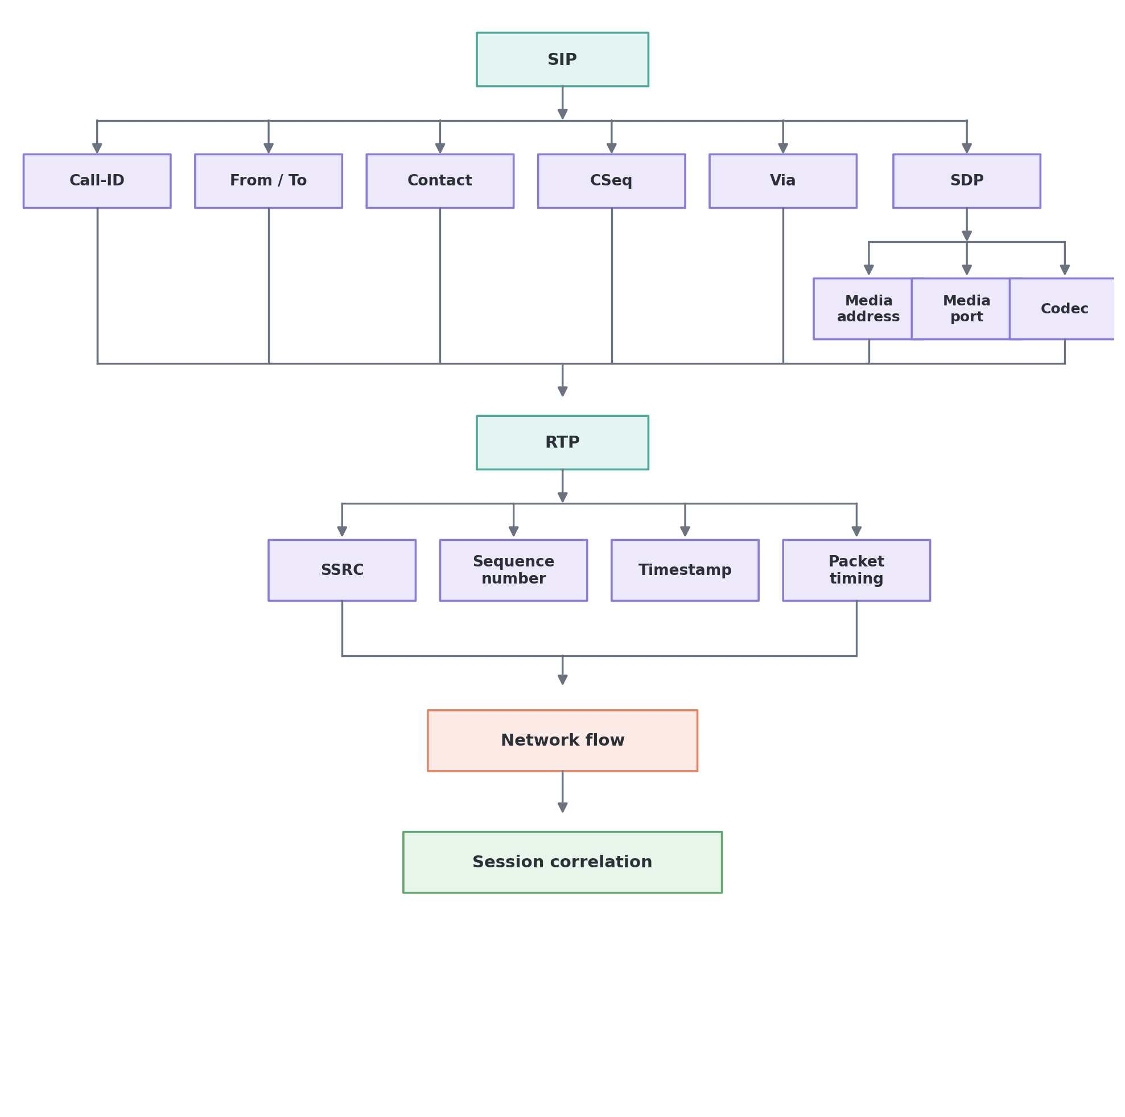
Figure 2. SIP signaling correlated with RTP media transport.
SIP provides signaling context, while RTP generally transports real-time media. SDP connects signaling with media-session parameters. Correlating these records can provide stronger session context than looking at an IP address alone.

9. Example: DNS + TLS + Network Flow
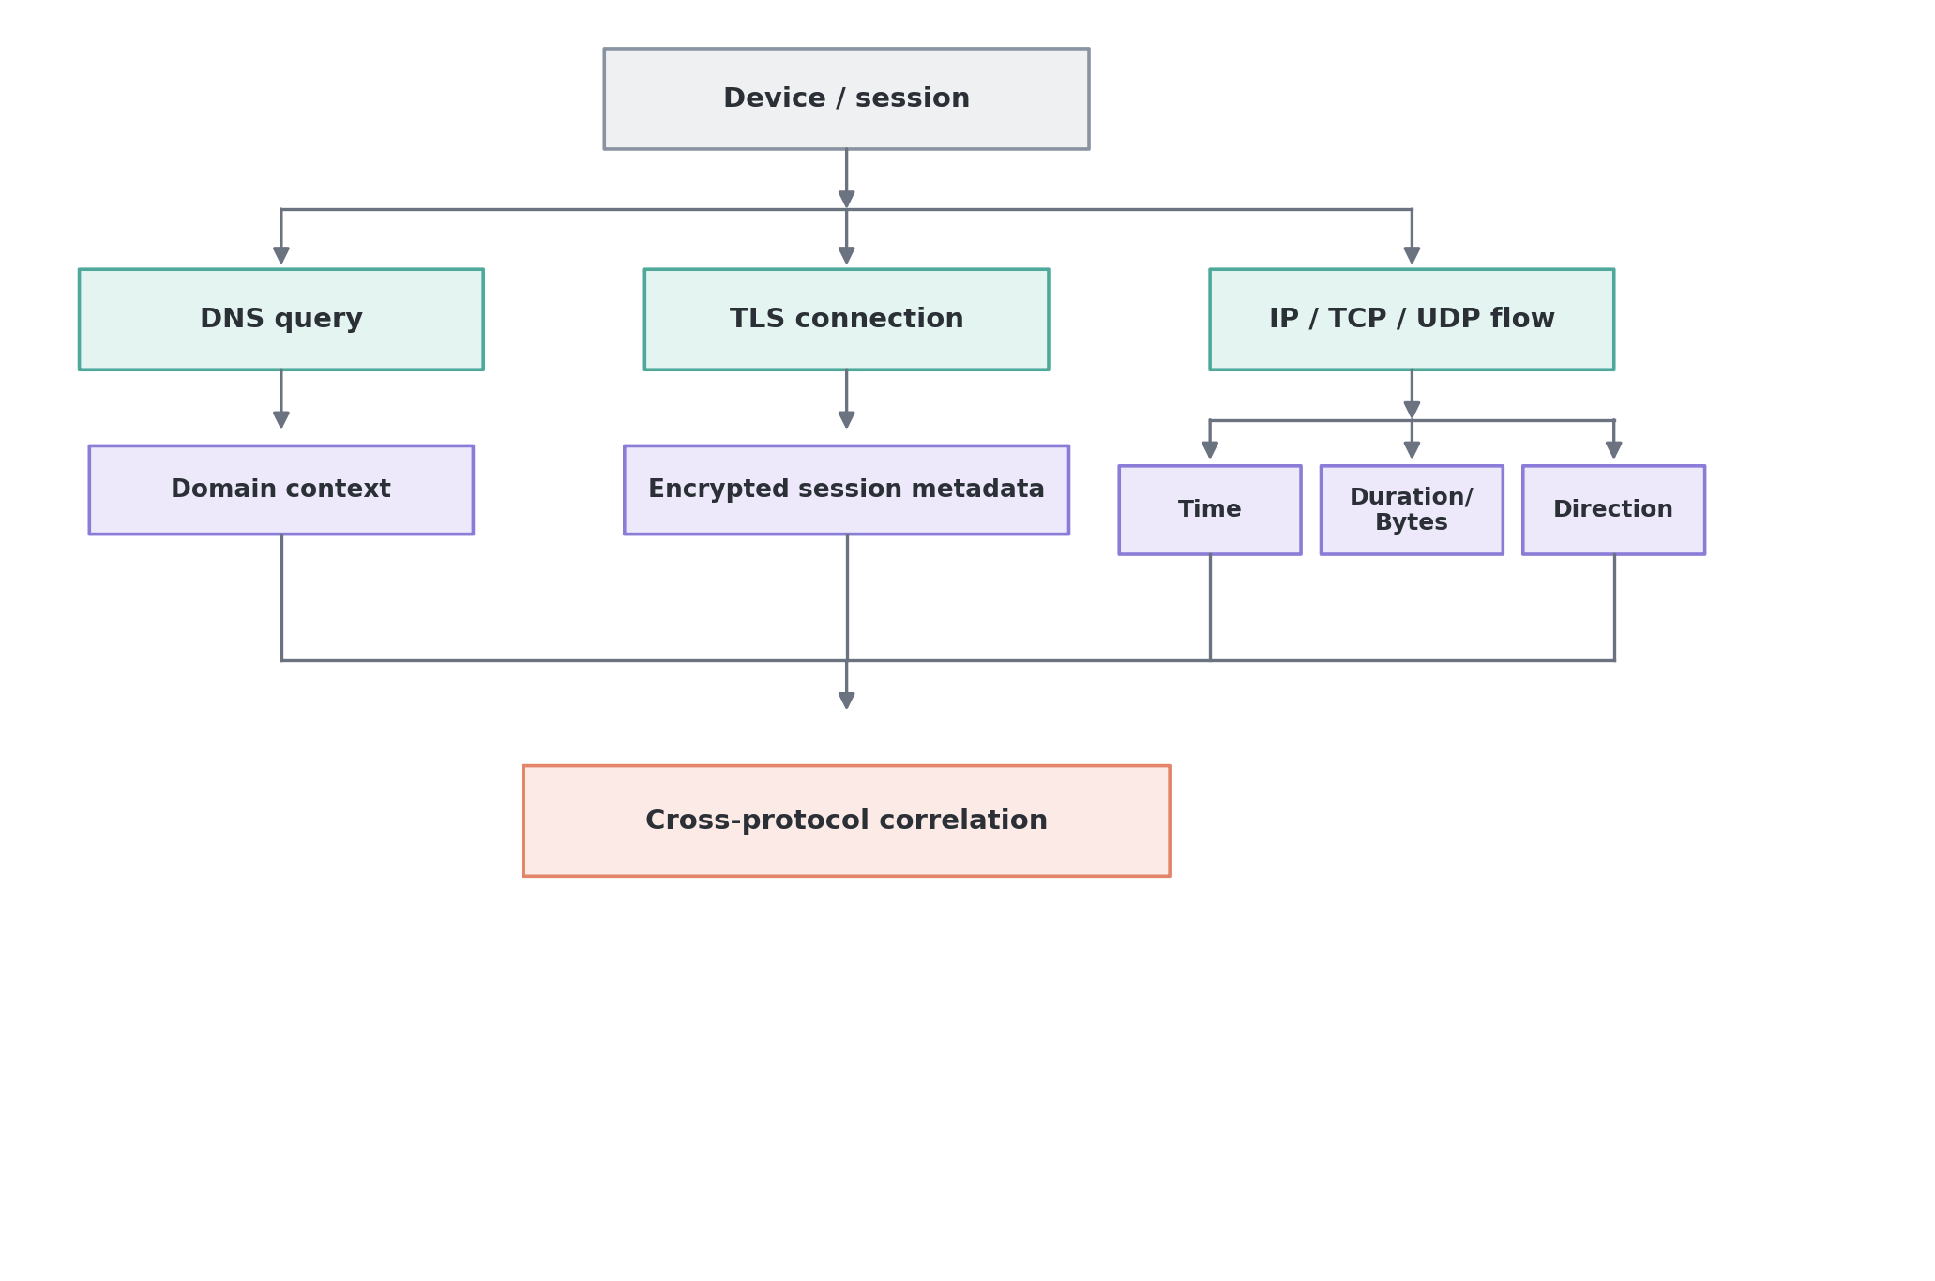
Figure 3. Cross-protocol correlation across DNS, TLS, and flow metadata.
Even when application content is encrypted, observable metadata can still provide useful context. The amount of information available depends on encryption, network location, protocol version, and collection point.

10. VPN, Tor, NAT, and Encryption: What Changes?
A major design problem is that the visible network path can change. A VPN can make the VPN server appear as the source to a destination. NAT can cause many devices to share a public address. Tor can separate the destination from the originating network address. Encryption can hide application content.
Therefore, the system must not assume that an IP address is a permanent identity.
Technique | Problem | Design response
VPN | Visible source address may be the VPN endpoint. | Record observation point, time, tunnel/session context, and other lawful metadata.
Tor | Destination generally sees a Tor exit rather than the origin. | Treat exit address as an observation, not as the person identity; correlate only with authorized multi-source evidence.
NAT | Many users can share one public IP. | Use timestamps, ports, network records, and authorized provider mappings where available.
DHCP/mobile addressing | Addresses can change. | Use time-bounded identifiers and session context.
Encryption | Payload/application content may be unavailable. | Use permitted metadata, protocol headers, endpoint telemetry, and authorized decrypted sources where available.

11. What Does Not Reliably Stay the Same?
There is no universal identifier that should be described as ‘never changing’ or ‘always traceable.’ The system stores every identifier with a timestamp, source, observation point, and validity period.
- Public IP address
- Private IP address
- Source/destination port
- DHCP-assigned address
- NAT mapping
- VPN endpoint address
- Tor exit address
- MAC address in environments where it is observable and may change
- Session identifiers such as GTP TEID or call/session IDs
- Application identifiers and device characteristics

12. Better Concept: Stable Relationships Instead of Permanent Identifiers
Rather than treating any single identifier as permanent, the architecture links identifiers observed at different times (Identifier A at T1, Identifier B at T2, Identifier C at T3) through shared session context, device/account context, communication relationships, and authorized records — producing a potential common entity with explicit confidence and evidence, rather than an assumed identity.
This does not mean that changing identifiers prove a common person. It means the architecture preserves the possibility of correlation while requiring evidence and confidence assessment.

13. Entity / Relationship Graph
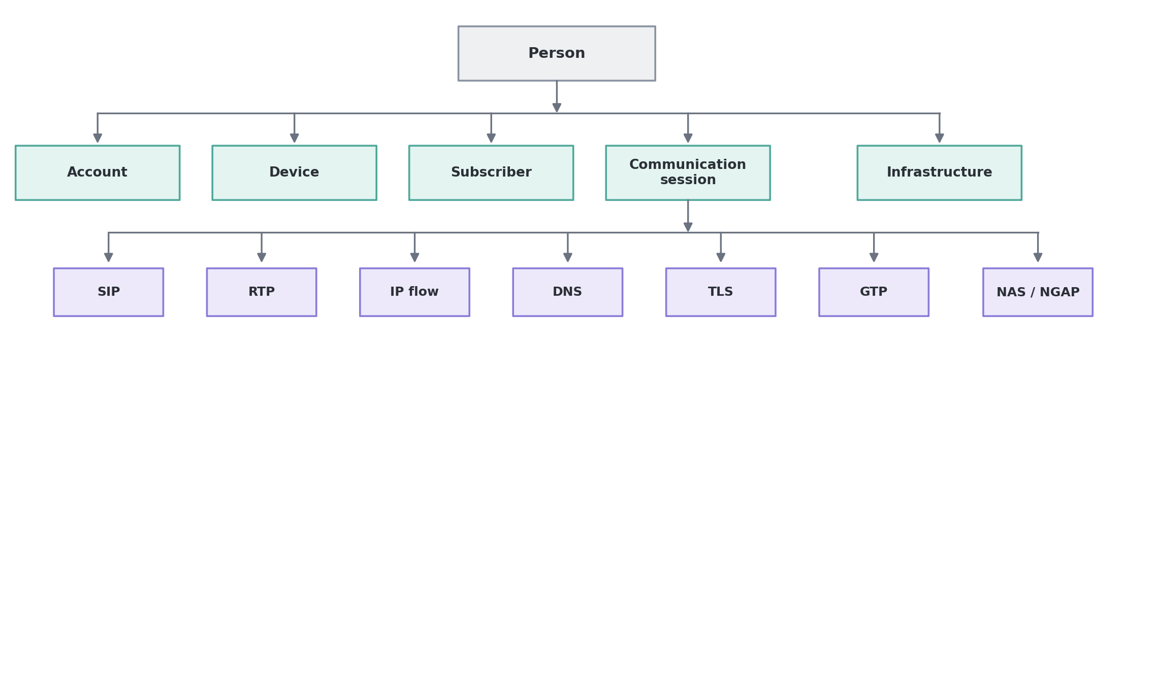
Figure 4. Entity/relationship graph rooted at a Person node.
Each relationship in the graph carries: timestamp, source, observation point, evidence type, confidence, and validity period.

14. Main Problems and Proposed Solutions
Problem | Proposed solution
Changing IP addresses | Do not use IP as the identity. Use time-bounded IP observations plus session and authorized network records.
VPN/Tor | Model them as network-path transformations. Preserve observation point and distinguish endpoint identity from origin identity.
Encryption | Use metadata and protocol-level information that is legitimately observable. Use endpoint or authorized decrypted sources where permitted.
NAT | Correlate public IP with timestamp, port/session information and authorized provider records.
Multiple protocols | Normalize fields into a common schema and correlate by time, session, endpoint and relationship.
Huge packet volume | Convert packets into flows and extracted events, then retain packet references for evidence.
False positives | Use baselines, multiple independent signals, confidence scores and analyst review.
False attribution | Separate technical entity resolution from person attribution and require authorized identity evidence.
Missing data | Track collection gaps, observation points and data quality instead of silently inferring missing values.
Privacy and legal constraints | Use explicit authorization, purpose limitation, access control, audit logs, retention controls and human review.

15. Proposed Technical Architecture
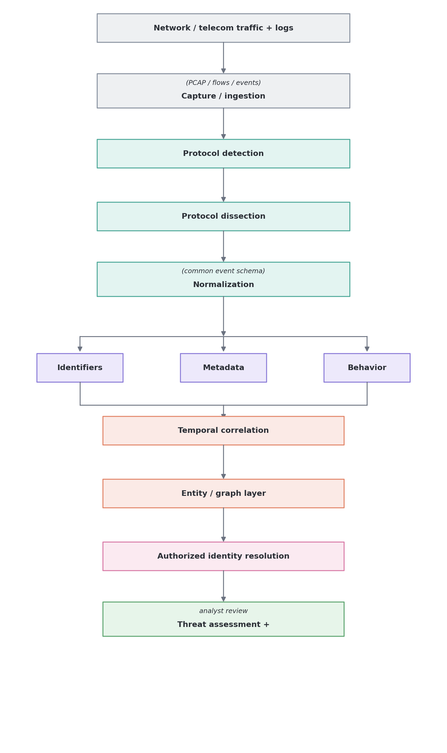
Figure 5. End-to-end technical architecture.

16. Common Normalized Event Schema
A common schema allows different protocols to be correlated consistently.
- event_id
- timestamp_start
- timestamp_end
- observation_point
- source_address
- destination_address
- source_port
- destination_port
- transport_protocol
- application_protocol
- session_id
- device_or_subscriber_identifier (when legitimately available)
- domain_or_service
- bytes
- packets
- direction
- protocol_fields
- related_event_ids
- evidence_source
- confidence

17. Example End-to-End Scenario
The following is a conceptual example for system design, not a claim that any individual pattern proves terrorism or malicious activity.
- Observation 1 — Device/session generates normal traffic.
- Observation 2 — A new communication relationship appears.
- Observation 3 — DNS activity changes from the historical baseline.
- Observation 4 — A SIP signaling session is observed.
- Observation 5 — SDP links the signaling session to a media session.
- Observation 6 — RTP flow appears in the same time window.
- Observation 7 — Network/session records provide additional telecom context.
- Observation 8 — Multiple observations are linked in the entity graph.
System output: “Entity E123 has a significant behavioral deviation and multiple correlated communication events.”
Not: “Entity E123 is a terrorist.”
Final identity attribution requires authorized identity evidence and analyst validation.

18. Threat Detection vs Target Identification
Stage | Question | Output
Detection | Is this activity unusual? | Anomaly / alert
Correlation | Are multiple events related? | Correlated activity
Entity resolution | Which device/account/session is involved? | Technical entity
Identity attribution | Which authorized identity record corresponds to the entity? | Identity candidate
Assessment | Does the evidence support a threat hypothesis? | Investigation priority
Analyst review | Is the evidence sufficient and reliable? | Validated / rejected hypothesis

19. MVP Scope
A manageable first prototype avoids trying to support every protocol at once.
- Input: PCAP files and/or prepared flow/event records.
- Core dissection: Ethernet, IPv4/IPv6, TCP, UDP, DNS, TLS metadata, HTTP metadata where available.
- Telecom extension: SIP, SDP, RTP, RTCP.
- Normalization: convert extracted fields into a common event schema.
- Correlation: time, session, endpoint and relationship based correlation.
- Graph: Device, IP, session, domain, communication and protocol relationships.
- Output: evidence timeline, correlated entities, anomaly indicators and confidence.
- Human review: every high-impact identity or threat conclusion should be reviewable and traceable to evidence.

20. What the Prototype Should Produce
Entity: E123
- 10:01:02 — DNS activity
- 10:03:11 — New network session
- 10:07:25 — SIP signaling
- 10:07:31 — RTP session
- 10:19:40 — Session termination
Observed relationships:
- E123 → Domain A
- E123 → Session S1
- S1 → SIP
- S1 → RTP
- S1 → Network Flow F1
Behavioral findings:
- New communication relationship
- Deviation from historical baseline
- Multiple correlated protocol events
Confidence: Medium
Decision: Requires authorized analyst investigation

21. Security, Privacy, and Evidentiary Requirements
- Operate only with appropriate legal and organizational authorization.
- Maintain chain of custody or equivalent evidence provenance for collected data.
- Store timestamps and observation points for every important observation.
- Keep raw evidence references so extracted fields can be verified.
- Use role-based access control and audit logs.
- Separate anomaly detection from identity attribution.
- Avoid treating unusual behavior as proof of criminal or terrorist activity.
- Use confidence scores and alternative explanations.
- Apply data minimization and retention controls appropriate to the authorized purpose.

22. Recommended Development Roadmap
- Phase 1: Learn packet/frame structure and protocol layering.
- Phase 2: Build PCAP ingestion and protocol identification.
- Phase 3: Implement or integrate protocol dissectors.
- Phase 4: Extract normalized fields and flow/session information.
- Phase 5: Build an event timeline.
- Phase 6: Add cross-protocol correlation.
- Phase 7: Build the entity/relationship graph.
- Phase 8: Add behavioral baselines and anomaly indicators.
- Phase 9: Add authorized identity-resolution interfaces.
- Phase 10: Add analyst dashboard, evidence drill-down, confidence and auditability.

23. Final Concept
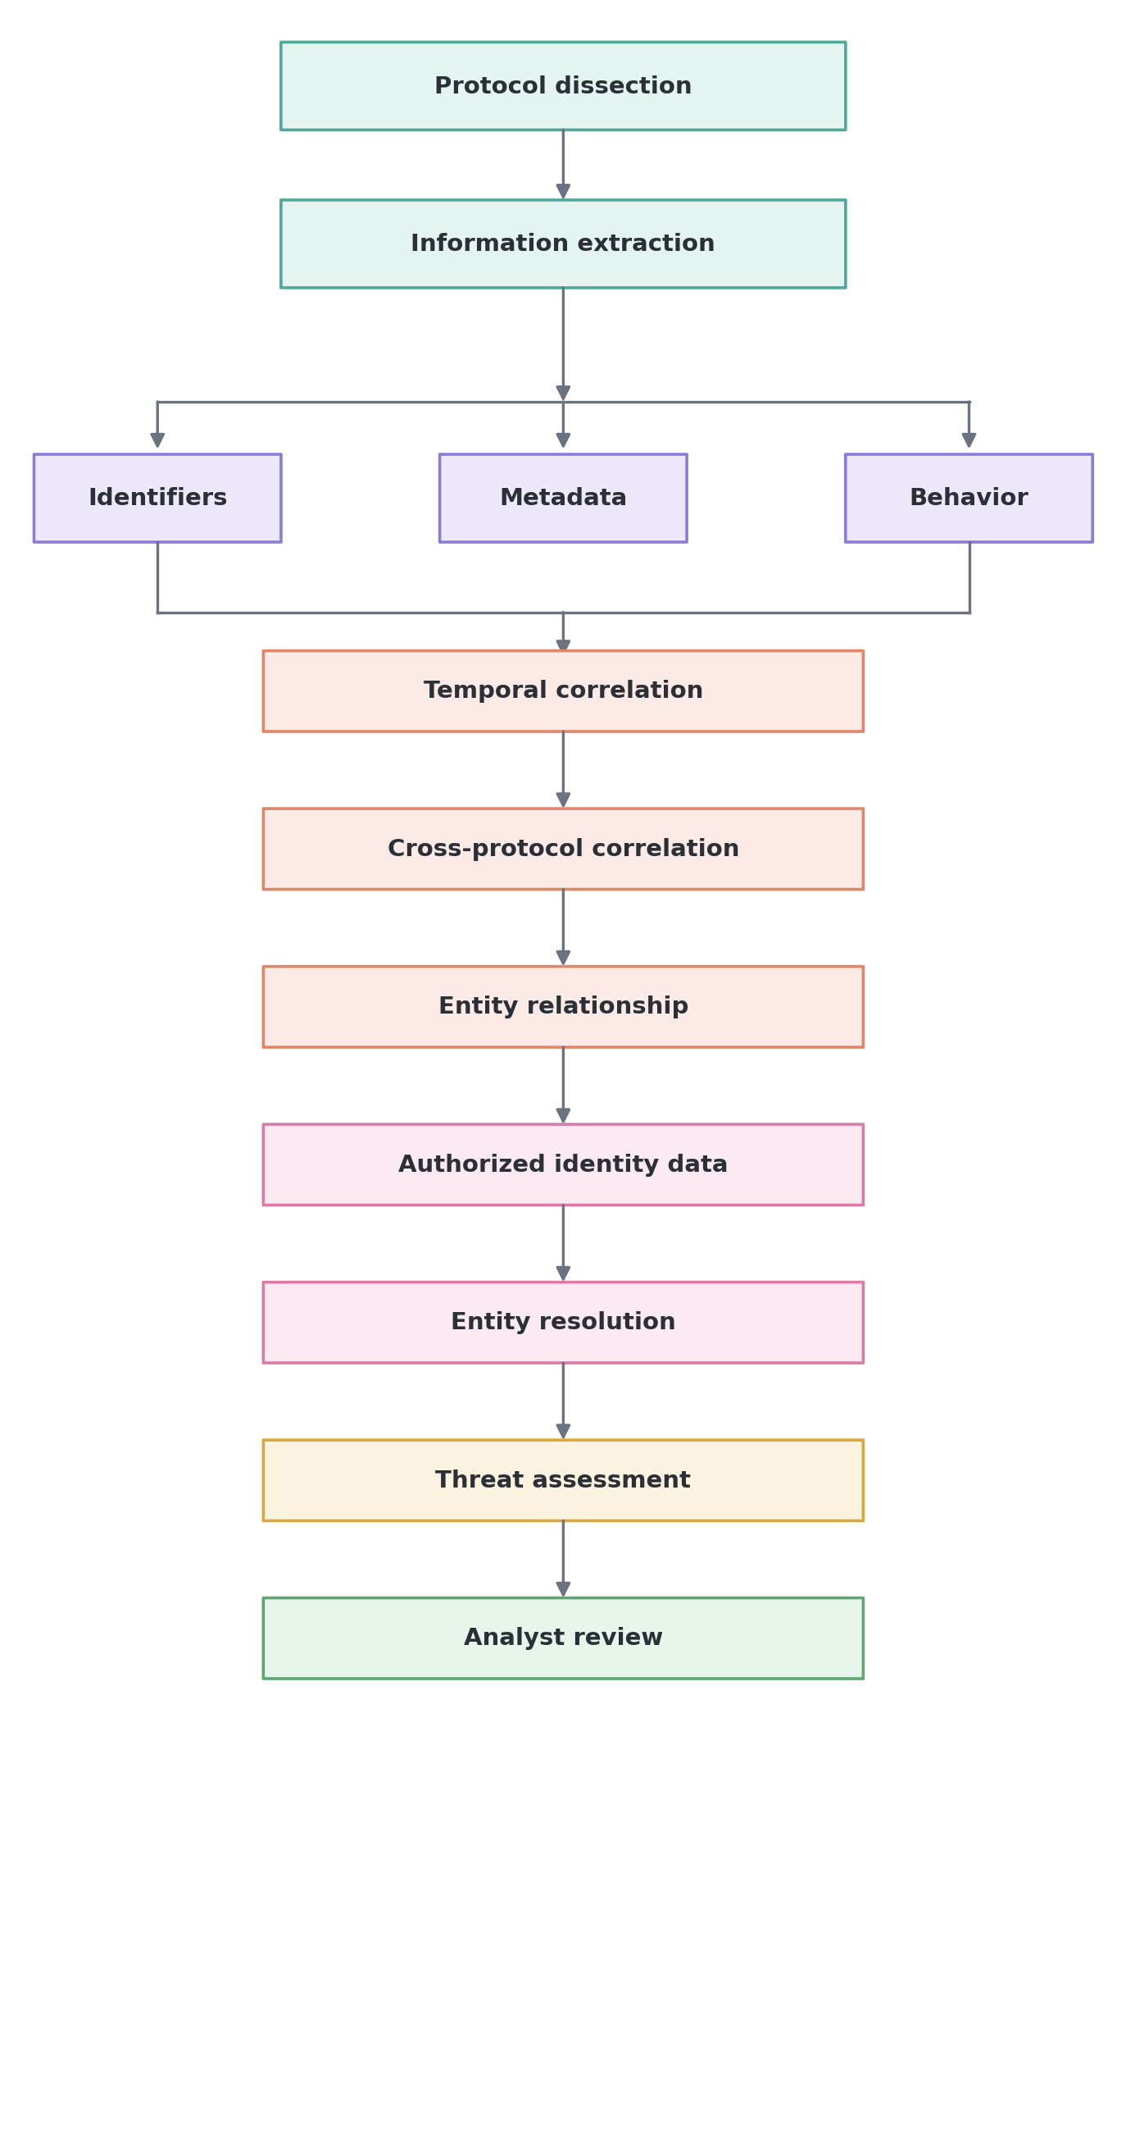
Figure 6. Final consolidated concept flow.
The strongest architecture is therefore not an IP-tracking system. It is a multi-source network intelligence and entity-correlation system. Protocol dissection is the foundation for converting raw network observations into structured evidence. Correlation provides context, graph relationships connect observations, and authorized identity records support real-world attribution.

